AWS NACL Hands-On Lab

Goal: Understand how allow/deny rules and rule priority work in Network ACL

1️⃣ Architecture
Resources naming format: studentname-*
Example (replace studentname with your name):
- EC2: studentname-ec2
- VPC: studentname-vpc
- Subnet: studentname-subnet
- NACL: studentname-nacl
- Security Group: studentname-sg
Network flow:
Internet
|
| (Security Group)
|
EC2 Instance
|
| (Subnet)
|
Network ACL
Important concept:
Feature | Security Group | NACL
Type | Stateful | Stateless
Rules | Allow only | Allow + Deny
Evaluation | All rules | Rule number order
Priority | No priority | Lower number = higher priority
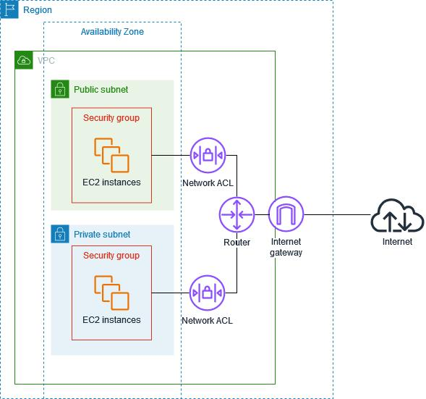

2️⃣ Step 1 — Create VPC
Create VPC
Name: studentname-vpc
CIDR:
10.0.0.0/16
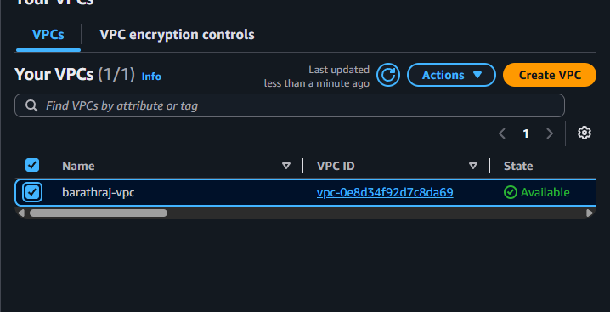

3️⃣ Step 2 — Create Subnet
Name: studentname-subnet
CIDR:
10.0.1.0/24
Availability zone: any
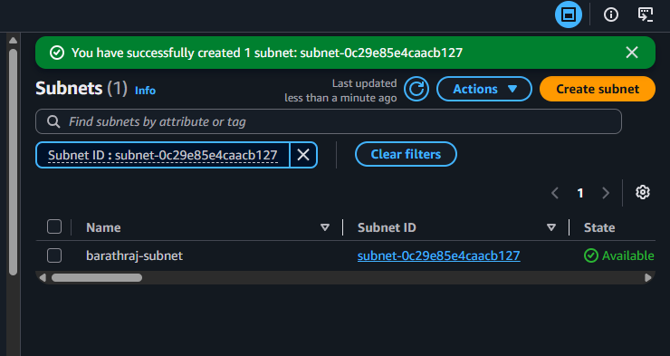

4️⃣ Step 3 — Create Internet Gateway
Create:
studentname-igw
Attach it to:
studentname-vpc
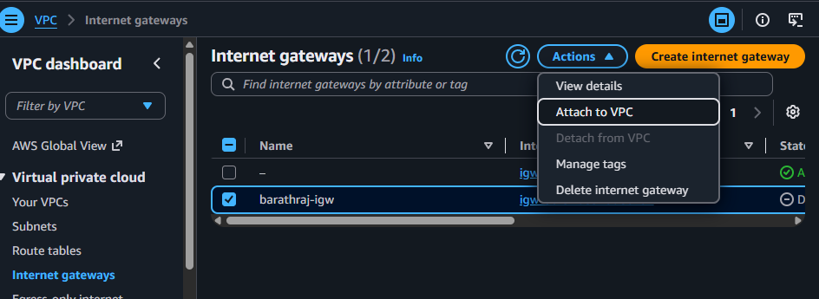

5️⃣ Step 4 — Create Route Table
Create route table:
studentname-rt
Add route:
0.0.0.0/0 → Internet Gateway
Associate with:
studentname-subnet
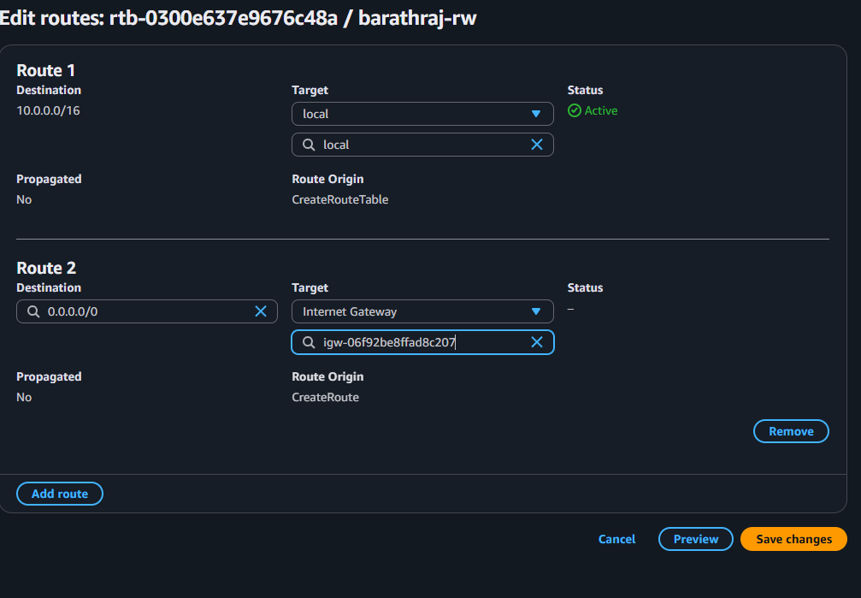

6️⃣ Step 5 — Create Security Group
Name:
studentname-sg
Inbound rules:
Type | Port | Source
SSH | 22 | My IP
HTTP | 80 | 0.0.0.0/0
ICMP | All | 0.0.0.0/0
Outbound:
Allow All
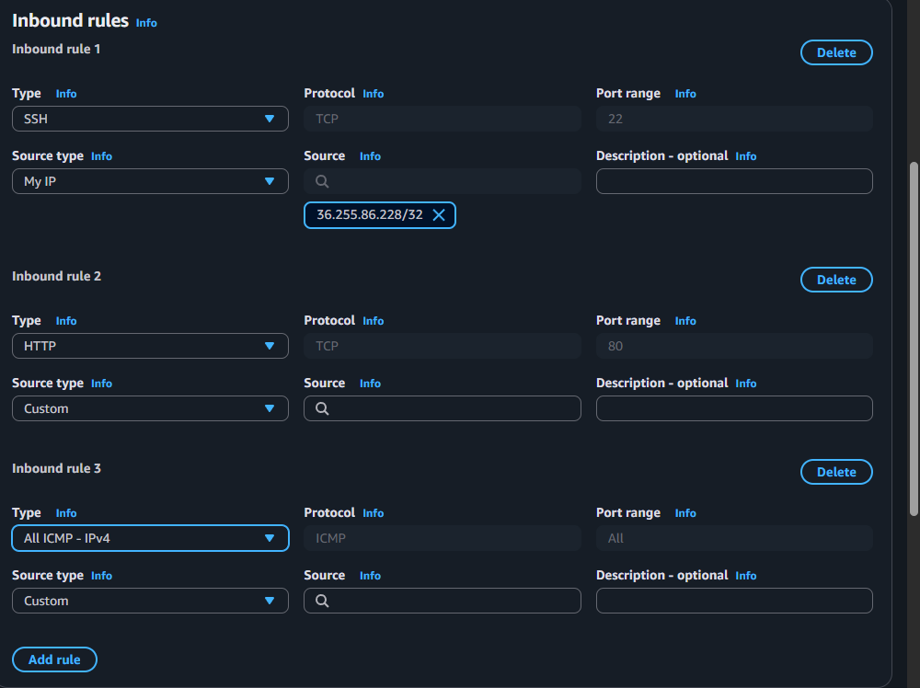
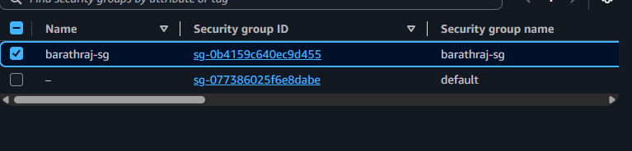

7️⃣ Step 6 — Launch EC2
Instance name:
studentname-ec2
Settings:
Option | Value
AMI | Amazon Linux
Instance type | t2.micro
Subnet | studentname-subnet
Security group | studentname-sg
Public IP | Enabled

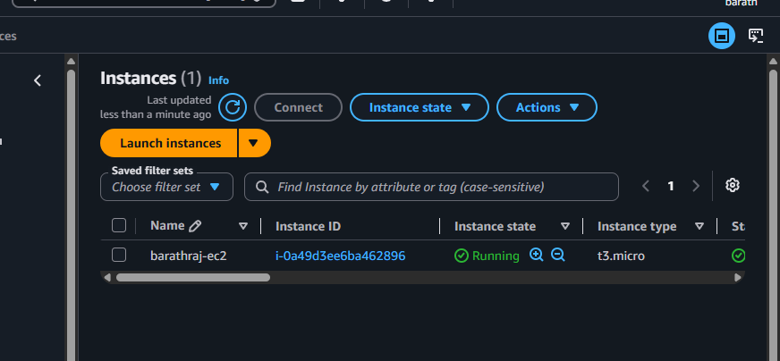
8️⃣ Step 7 — Validation (Before NACL rules)
Test from your laptop.
SSH
ssh -i key.pem ec2-user@public-ip
Ping
ping public-ip
HTTP test
On EC2 install web server:
sudo yum install httpd -y
sudo systemctl start httpd
sudo systemctl enable httpd
Test in browser:
4
All should work now.
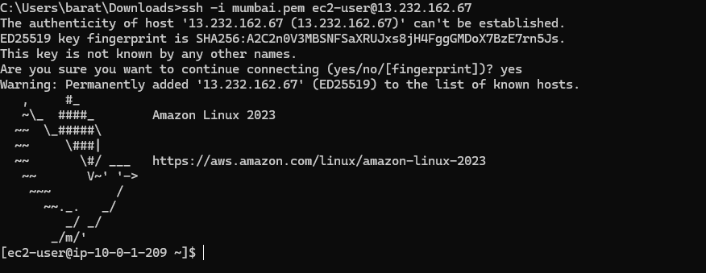

9️⃣ Step 8 — Create Custom NACL
Create NACL:
studentname-nacl
Attach to subnet:
studentname-subnet
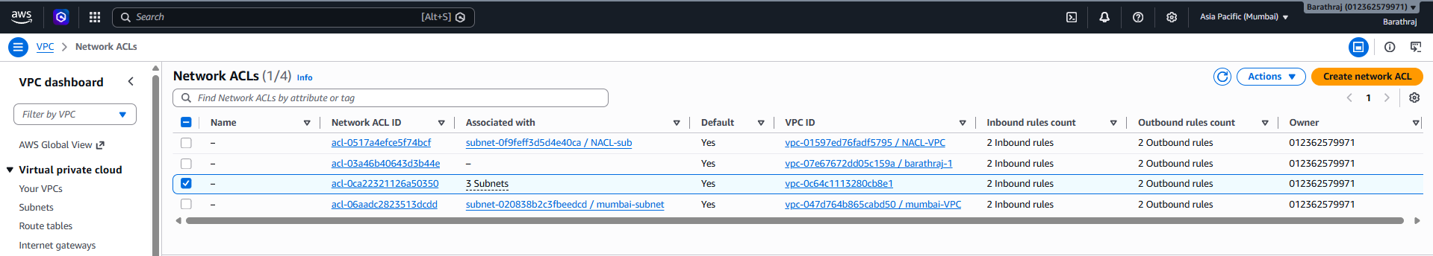
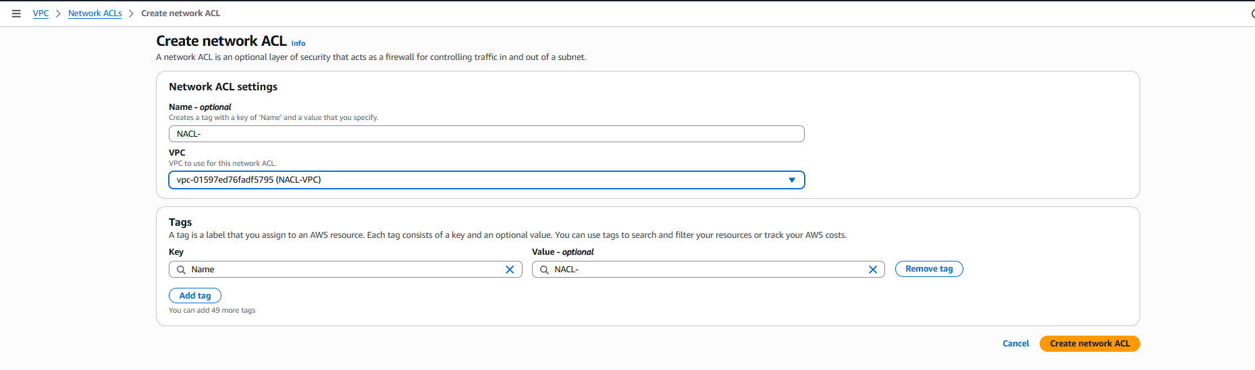
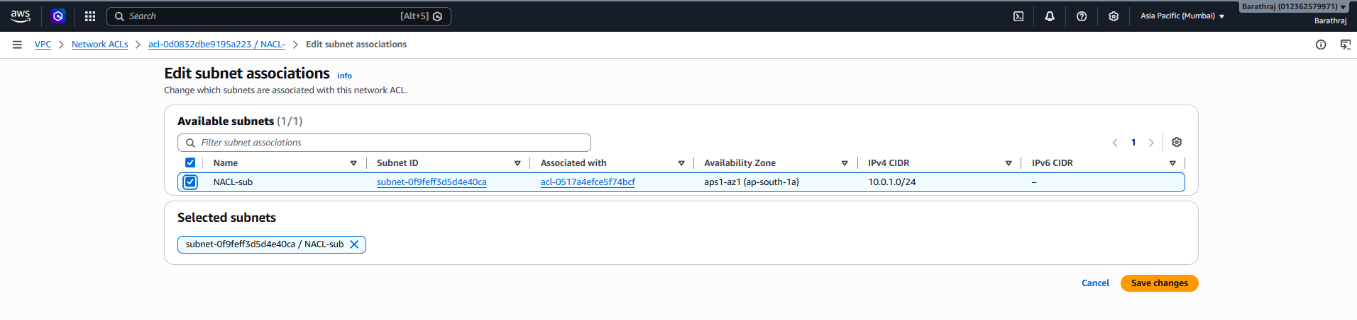

🔟 Step 9 — Add Allow Rules
Inbound rules:
Rule | Type | Port | Source | Allow/Deny
100 | SSH | 22 | 0.0.0.0/0 | ALLOW
110 | HTTP | 80 | 0.0.0.0/0 | ALLOW
* | ALL | ALL | ALL | DENY
Outbound rules:
Rule | Type | Port | Destination | Allow/Deny
100 | ALL | ALL | 0.0.0.0/0 | ALLOW
Validate again:
- SSH works
- HTTP works
- Ping works
- 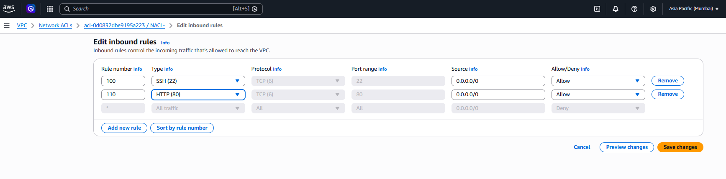
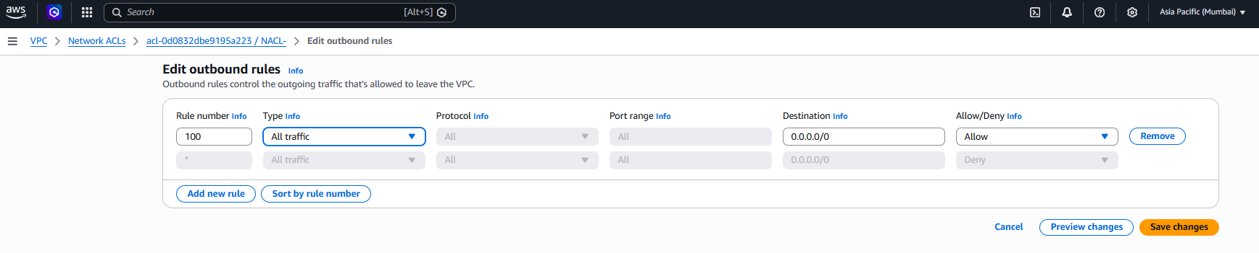
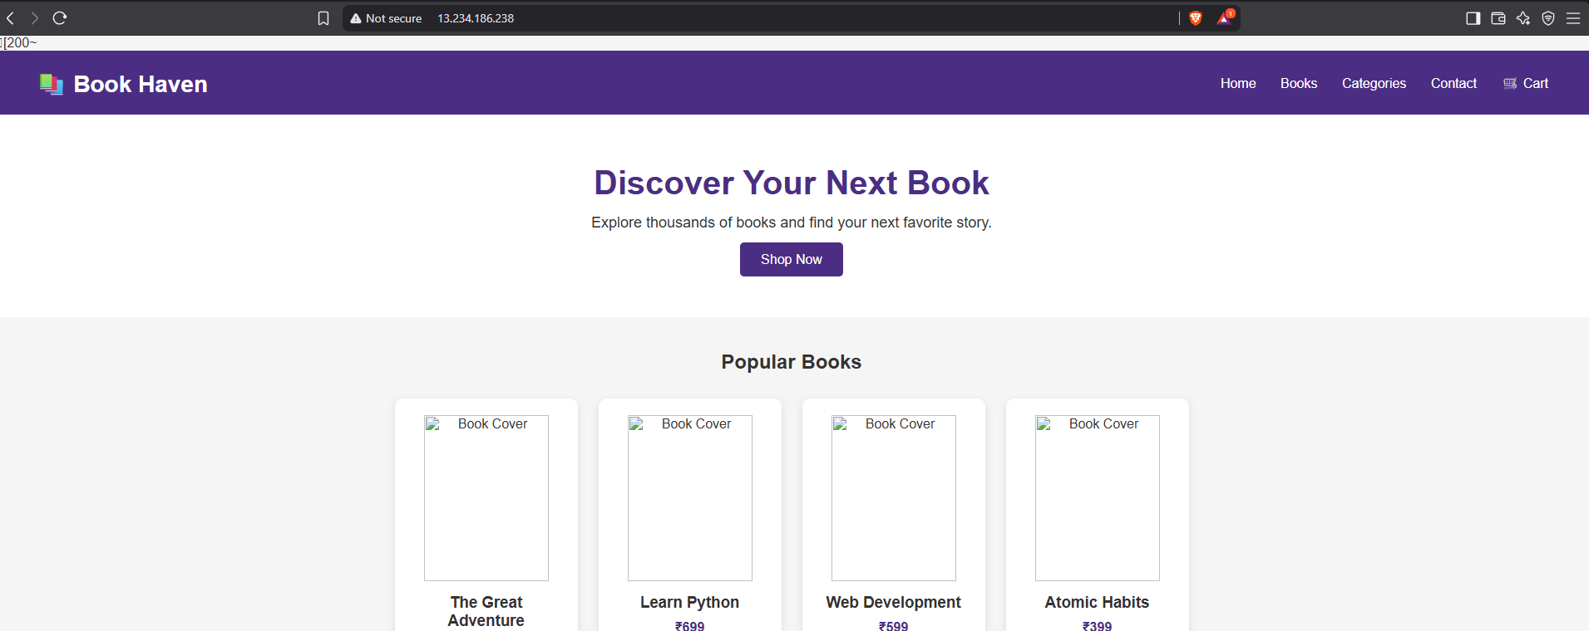

1️⃣1️⃣ Step 10 — Deny SSH Using Priority
Now add rule 99
Inbound rules:
Rule | Type | Port | Source | Action
99 | SSH | 22 | 0.0.0.0/0 | DENY
100 | SSH | 22 | 0.0.0.0/0 | ALLOW
110 | HTTP | 80 | 0.0.0.0/0 | ALLOW
Important concept:
99 is evaluated first
Result:
Test | Result
SSH | ❌ BLOCKED
HTTP | ✅ WORKS
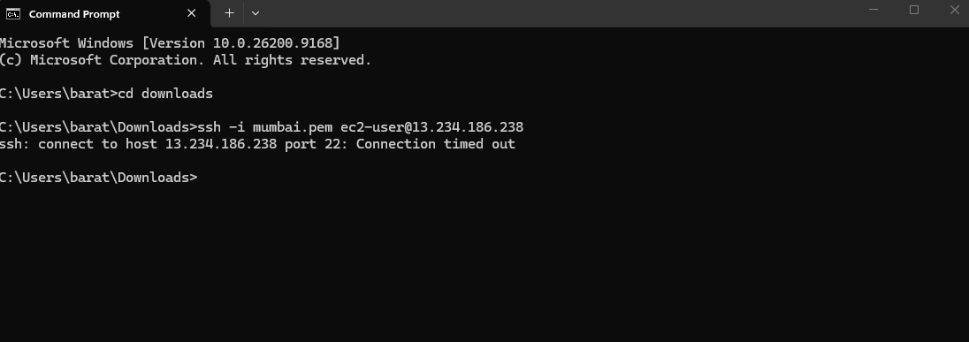
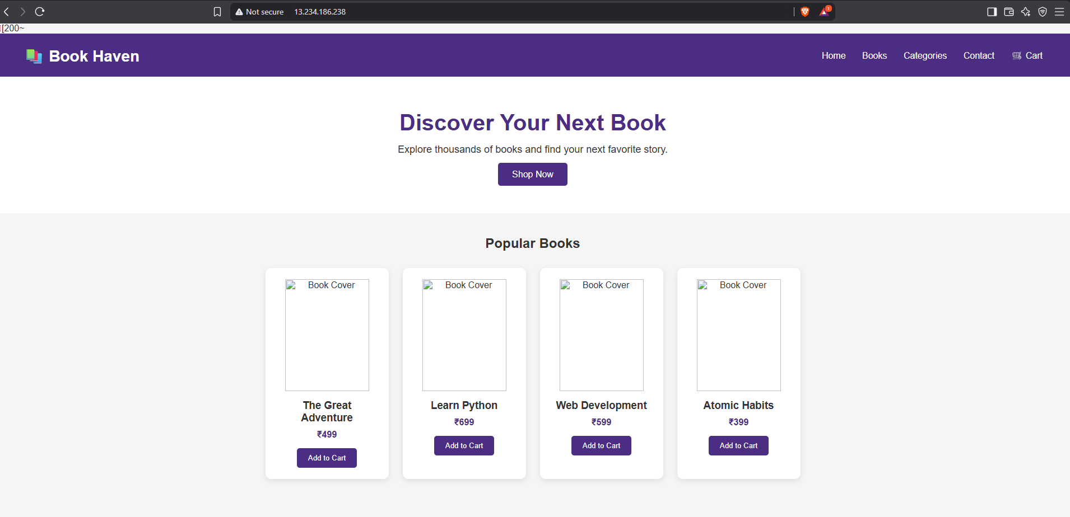

1️⃣2️⃣ Step 11 — Deny HTTP
Add rule:
Rule | Type | Port | Action
98 | HTTP | 80 | DENY
Rules now:
Rule | Port | Action
98 | 80 | DENY
99 | 22 | DENY
100 | 22 | ALLOW
110 | 80 | ALLOW
Result:
Test | Result
SSH | ❌
HTTP | ❌
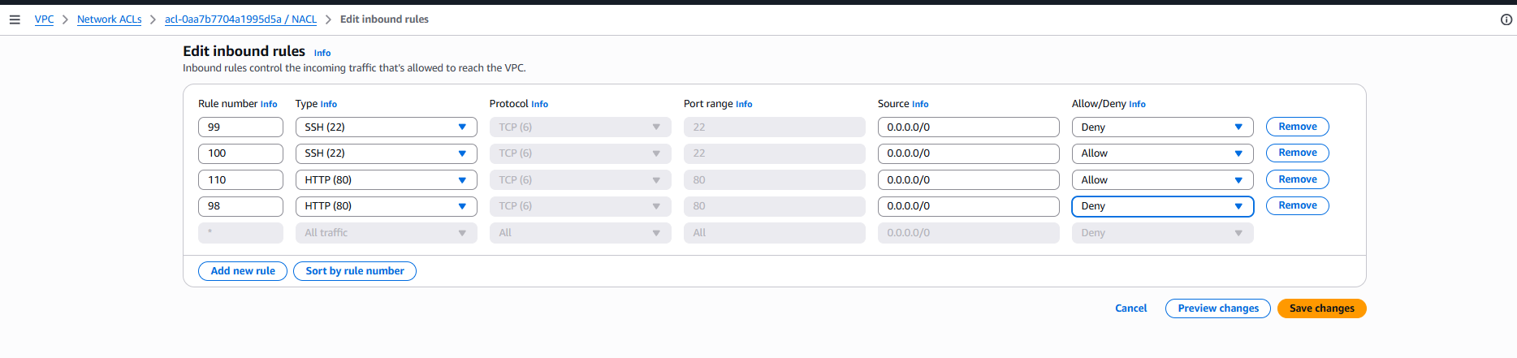
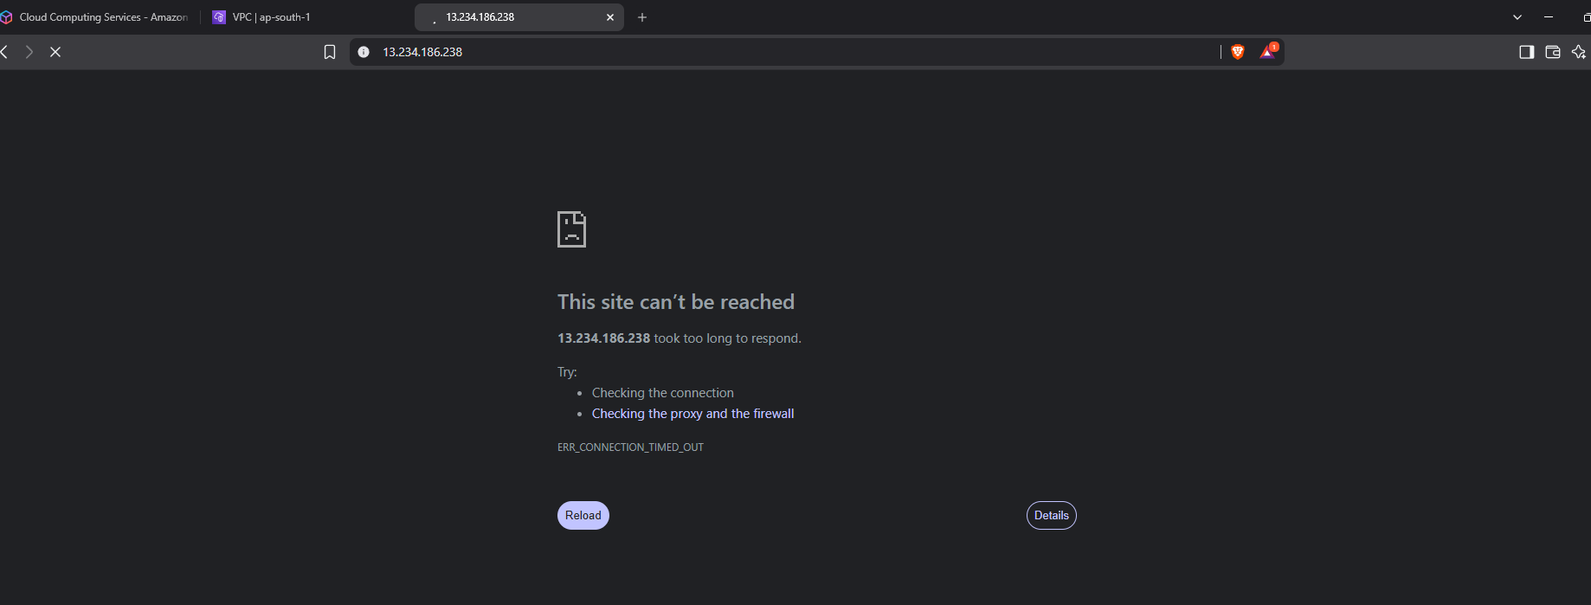

1️⃣3️⃣ Step 12 — Test Outbound Blocking
Edit outbound rules:
Rule | Port | Action
99 | 80 | DENY
100 | ALL | ALLOW
SSH into EC2 and test:
curl google.com
Result:
Connection blocked
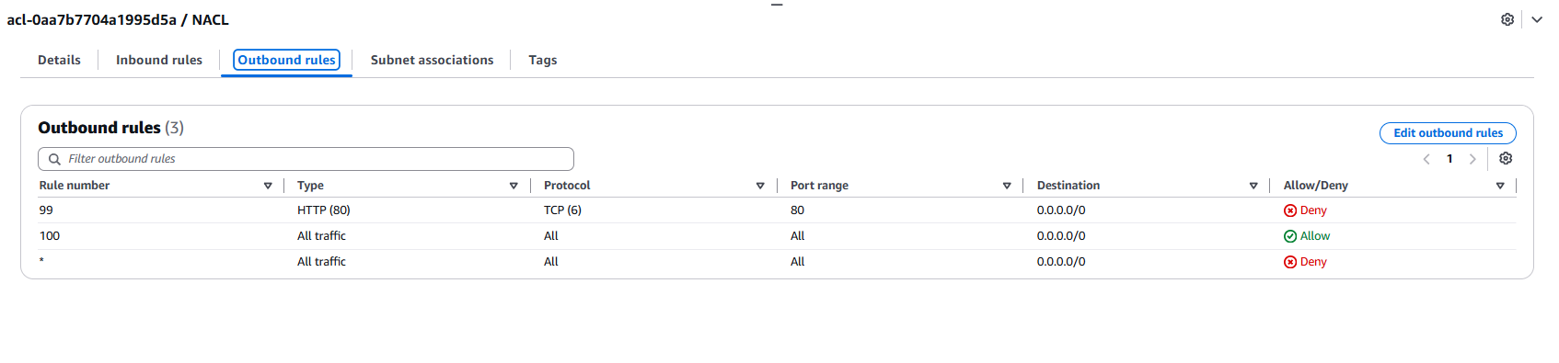
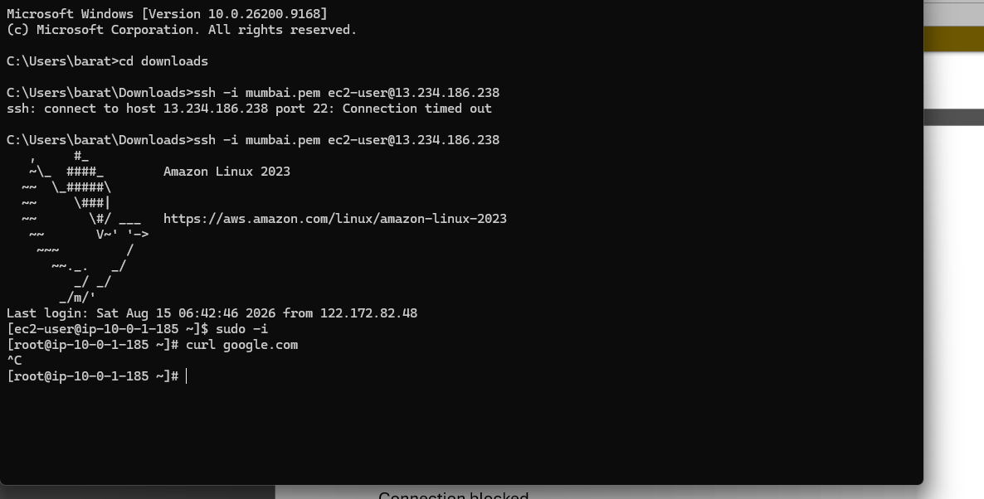

1️⃣4️⃣ Key Learning
Important NACL concepts:
1️⃣ Lower rule number = higher priority
Example
Rule 99 → evaluated first
Rule 100 → evaluated second

2️⃣ NACL is stateless
If inbound allows:
SSH 22
Outbound must allow:
Ephemeral ports (1024-65535)

3️⃣ Implicit DENY
Last rule always:
DENY ALL

1️⃣5️⃣ Interview Question From This Lab
Question:
If rules are
99 DENY SSH
100 ALLOW SSH
What happens?
Answer:
SSH blocked
Because rule 99 is evaluated first.

1️⃣6️⃣ Real Cloud Architect Scenario
Companies use NACL to:
- Block malicious IP ranges
- Restrict subnet traffic
- Protect databases
- Implement network segmentation
Example:
Public subnet → allow HTTP
Private subnet → deny internet
DB subnet → allow only app subnet

